Friends,

Eastern Oklahoma Presbytery has been in partnership with the Church of Central Africa Presbyterian Synod of Livingstonia for over 20 years. In that time, we have shared struggles and celebrations, mutually encouraged one another, and worked hard to be true partners in ministry with our friends in Malawi, Africa. Personal relationships and face-to-face interactions have served to strengthen our partnership. For this reason, the EOP Malawi Network has committed to sending and receiving delegations each year.

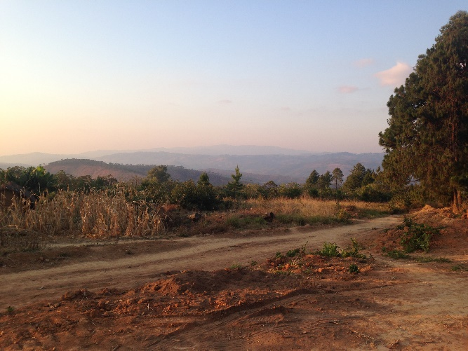
In November, we hosted a Malawian delegation in Oklahoma. Our partners traveled to various churches, participated in ministry opportunities, and experienced all that Oklahoma had to offer. Now, EOP is organizing a reciprocal two-week Listening and Learning Mission to Malawi in July of 2020; tentatively July 13-24. Our goal is to send 8 -10 people on this trip who have a willingness to listen and learn from our partners and experience all the hospitality and culture Malawi has to offer.

One of the questions asked of any mission trip is, “What will we be doing?” This trip is less about doing and more about being together with our partners in ministry. That doesn’t mean this will be a leisurely vacation! Participants will endure a long flight and lots of walking. An up-to-date passport and immunizations are required. But the preparation is worth it to experience Malawi’s legendary hospitality, travel the countryside, tour church facilities and mission stations, attend and participate in worship services, learn more about the church’s mission to the whole person, and forge lasting relationships with our sisters and brothers in Christ.

This year, we hope to engage people who have never been to Malawi. In order to facilitate new participant involvement, the EOP Malawi Network has created scholarship opportunities. These scholarships are available to participants who have never visited Malawi:
- 2 full scholarships for 2 Native American Participants
- 2/3 scholarships for participants in our ministry areas of focus:
  - Education (Teachers, Administrators, Students, Christian Educators, etc.)
  - Medicine (Nurses, Doctors, Techs, Patient Advocates, etc.)
  - Technical Training (Farming, Computer Science, Welding, Mechanics, Carpentry, Electricians, IT, Plumbing, etc.)
  - Youth (A Youth Under 20 or Someone in Youth Ministry)

Any other participant whose application is accepted will receive ⅓ funding from the presbytery, regardless of whether they have traveled to Malawi. Preliminary cost estimates (including airfare, room, and board) are between $3,000-3,500 per person. Our hope is that those who apply might receive ⅓ funding from their congregation, leaving the individual to cover the remaining $1,000-1,200.

Trip participants will attend orientation sessions to learn basic language and other essential skills for engaging our partners. There is an expectation that all attendees stay engaged in the EOP Malawi Network when they return by attending quarterly meetings, participating in partnership activities, and being available for presentations about their experience.

Prayerfully consider if this is something God is calling you to do. When I visited Malawi 2 years ago, I had no idea what a life changing trip it would be. I cherish the experience and thank God for the relationships that were formed.

The Listening & Learning Mission application deadline is April 13, 2020.

Please contact me with questions, concerns, or enthusiasm.
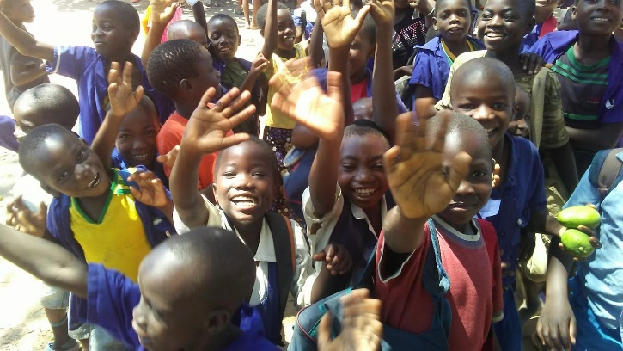
Grace & Peace,

Rev. Kate Hogue
EOP Malawi Moderator
918-742-5528 (Church Office)
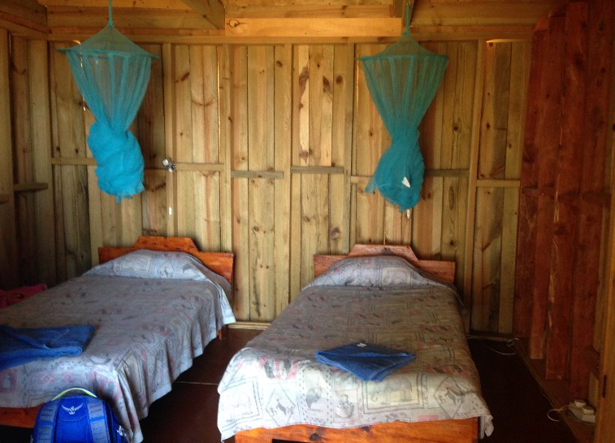
Kate@JohnKnoxChurch.org
